
LAPORAN PRAKTIKUM

- Identitas Praktikum
Nama MK : Praktikum Pemrograman Berorientasi Objek
Kode MK : CAK2KAB4
Bobot SKS : 3 SKS
Tempat : Lab MM
Hari, tanggal : 06-03-2026
Jam : 13.00 - selesai
Topik praktikum : Modul-2
- Identitas Mahasiswa
Nama lengkap : DZAKI KHOTHIR
NIM : 103112400113
Program Studi : S-1 Teknik Informatika
- Algoritma / studi kasus (jika ada) & Penjelasan
- Kode Program & Penjelasan
- Hasil Running Program

Code
import java.util.Scanner;

public class App {

public static void main(String[] args) {
Scanner input = new Scanner(System.in);
System.out.print("Masukkan jumlah deret: ");
int n = input.nextInt();

int a = 0, b = 1;
int total = 0;
int max = 0, min = 0;
int genap = 0, ganjil = 0;

for (int i = 0; i < n; i++) {

int fib;

if (i == 0){
fib = 0;
}else if (i == 1) {
fib = 1;
}else {
fib = a + b;
a = b;
b = fib;
}

System.out.print(fib + " ");

total += fib;

if (i == 0) {
max = fib;
min = fib;
}

if (fib > max) {
max = fib;
};

if (fib < min) {
min = fib;

};

if (fib % 2 == 0) {
genap++;
}
else {
ganjil++;
}
}

System.out.println("\nTotal = " + total);
System.out.println("Rata-rata = " + (double) total / n);
System.out.println("Max = " + max);
System.out.println("Min = " + min);
System.out.println("Genap = " + genap);
System.out.println("Ganjil = " + ganjil);
}
}

Output
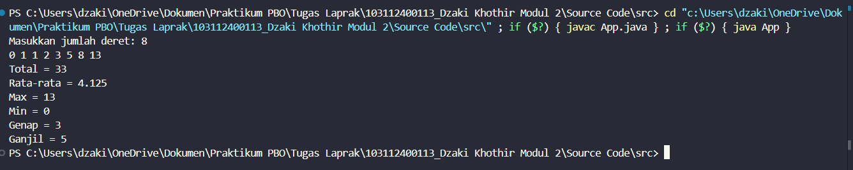

FLOWCHART

